TC-DISP-008
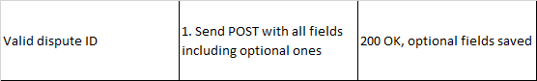
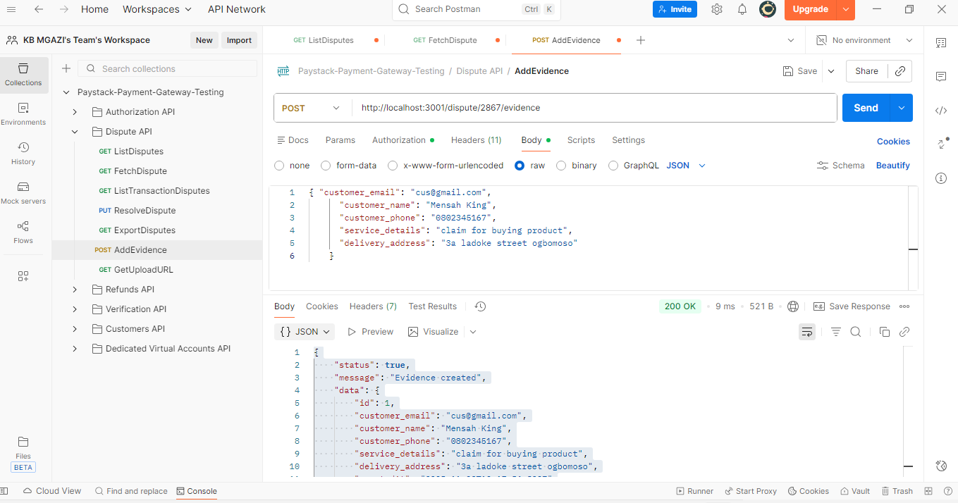
Request:
{ "customer_email": "cus@gmail.com",
"customer_name": "Mensah King",
"customer_phone": "0802345167",
"service_details": "claim for buying product",
"delivery_address": "3a ladoke street ogbomoso"
}

Response:
{
"status": true,
"message": "Evidence created",
"data": {
"id": 1,
"customer_email": "cus@gmail.com",
"customer_name": "Mensah King",
"customer_phone": "0802345167",
"service_details": "claim for buying product",
"delivery_address": "3a ladoke street ogbomoso",
"createdAt": "2025-11-20T13:17:56.899Z"
}
}

